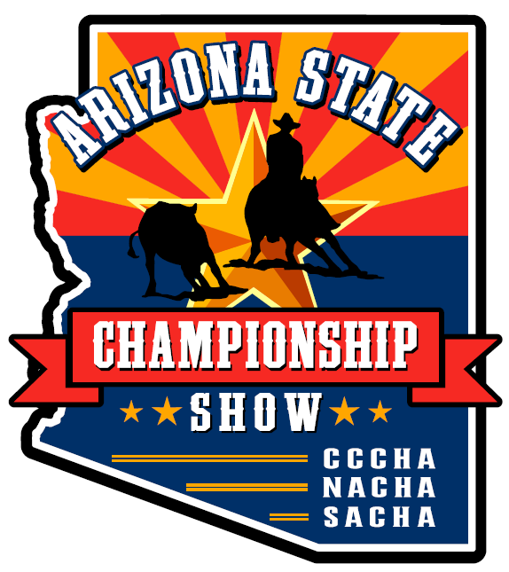
Vendor Information - 2023
This year’s 2023 Arizona State Cutting Championship Show, will be held on December 15th, 16th & 17th, 2022. Again, this year, we are providing free vendor space to our sponsors and to other interested vendors (with products, services and educational information related to equines, the sport of cutting and the western lifestyle). Vendor space is somewhat limited, with priority reservation and placement going to our paid sponsors first. Other interested vendors will be placed in spaces based on reservation date and approval by the show committee. In some cases, we may need approval by Horse Lover’s Park or their food service contractor, as necessary. Vendors will be screened to ensure that the theme of the Championship Show and the products, services and educational efforts of the vendors are appropriate to the event. Please take the time to read our mission statement at the bottom of this notice and take the time to visit our websites at www.AzCuttingChampionship.com, www.cavecreekcutting.com, www.northernazcutting.com and www.sachacutting.com or look up us on Facebook to familiarize yourself with our sport and our audience/participants.
- This year’s event will be held at Horse Lover’s Park located at 19224 N. Tatum Blvd., Phoenix, AZ., on Friday December 15th through Sunday, December 17th.
- This is a championship horse show competition and clinic first and foremost. Vendors must be cognizant of this and not cause excessive commotion and distraction to our competitors. Vendors must complete their setup before 8 AM each day to minimize disruption to the horses and riders in the competition. Horse Lover’s Park will be open to vendors beginning on Friday, the 15th. Please understand, there is no security at the site, so plan accordingly. You must have your setups dismantled and removed before 8:00PM on the last day of the show (Sunday, December 17th). Vendors are responsible for cleanup of their space prior to leaving Horse Lover’s Park.
- Vendors must be approved by show management and must be appropriate to horses and their owners, or the western lifestyle. Show management will provide approval or disapproval well in advance of the show. Vendor space requests must be received by November 12th and must include your evidence of the required insurance. Vendors will be notified the following week of approval or denial.

Vendors will need to provide vendor insurance with additional insureds named on the insurance certificate. “Friends of Horse Lovers Park, its officers, officials, agents, employees, and volunteers, Bert and Megan McGill, AE Management LLC, its employees, officers, officials, agents, and volunteers, LCS-Westminster partnership IV LLP, and the City of Phoenix, its officers, officials, agents, employees and volunteers, volunteers and staff of NACHA, CCCHA and SACHA”.
- Limits of coverage and the list of additional insureds are included on the separate document; (Vendors at the AZ State Championship Show will be required to carry $100,000 per occurrence and in the aggregate– per HLP site manager Megan McGill)
- You will be declined if your insurance paperwork does not match with our insurance requirements. Please thoroughly read the Horse Lover’s Park Insurance Requirement document: VENDOR-hlpcertificateofinsurance.
- Vendors, who have products for sale, are required to provide a TPT License number with their vendor space request form. Said license/number must be obtained by and at the expense of the vendor. For questions, please contact the Arizona Department of Revenue at 602-255-3381 or https://azdor.gov/transaction-privilege-tax/tpt-license/applying-tpt-license. Vendors are responsible for complying with all applicable local, state, or federal laws, regulations and fees.
- Paid sponsors will have priority placement within the designated vendor area.
- This is an outdoor event during December so weather may be unpredictable. Please plan accordingly.
- Vendors will be responsible for providing their own tents, backdrops, booths, tables and equipment necessary for their operation as well as their own labor to erect, dismantle and operate their business.
- Vendor space will be limited to an approximate 12 x 12 footprint which should easily accommodate a 10 x 10 EZ up style tent. If you have a larger space need please contact Susan Baxter 928-379-2339 so we can see how we can accommodate your space needs. We have room for a few larger sized product trailers.
- Vendors will be responsible for safe keeping and securing their items both during the day and overnight. Horse Lover’s Park, City of Phoenix, Arizona State Championship Show, CCCHA, NACHA, SACHA and their agents will not be held responsible for theft, damage or other issues related to our vendors.
- Vendors who have food or beverage items to sell must be approved through Horse Lover’s Park’s official food vendor. We will tentatively reserve your space pending the approval. Please submit the list of food and/or beverages on your space request form. Vendors with food or beverage items must comply with any and all City of Phoenix and Arizona state health department regulations.
- There is no water available in the vendor area.
- Electricity is limited at the facility. Please indicate on your reservation form if you will need electricity. A quiet generator will be allowed, but please note that on your space request. We will notify you as quickly as possible if we can accommodate your needs.
  - You should plan on providing your own heavy duty, outdoor electrical extension cord with multi plug as you may have to share electrical resources and your location may not be directly next to the HLP electrical jack.

Please return your Vendor Space Request Form as an email attachment and send it to info@AzCuttingChampionship@gmail.com.

If you have questions please contact Susan Baxter, our vendor chairperson at 928-379-2339

Mission Statement
The Arizona State Championship is dedicated to promoting growth within the sport of cutting by providing grassroots cutter the opportunity to receive statewide recognition. The Arizona State Championship will also provide a platform for information demonstrations to further promote education and awareness of the sport of cutting.

Thank you.

